ANNIE HOGAN

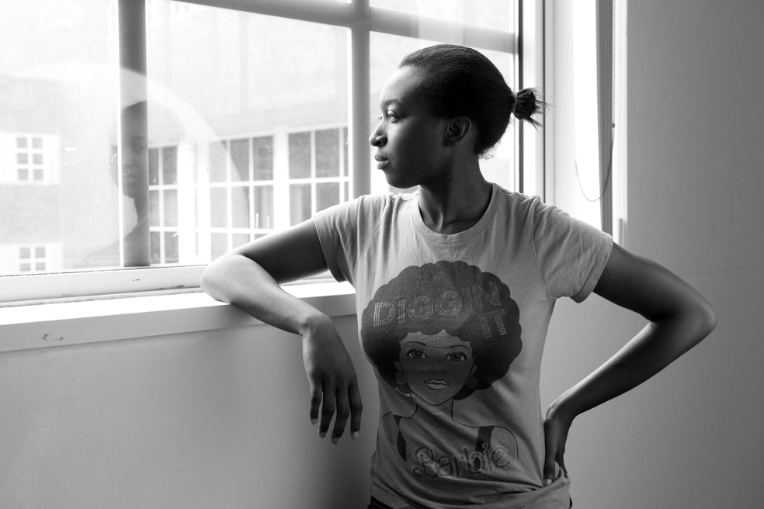

Shardé, 20” x 30”, Pigment print, 2014

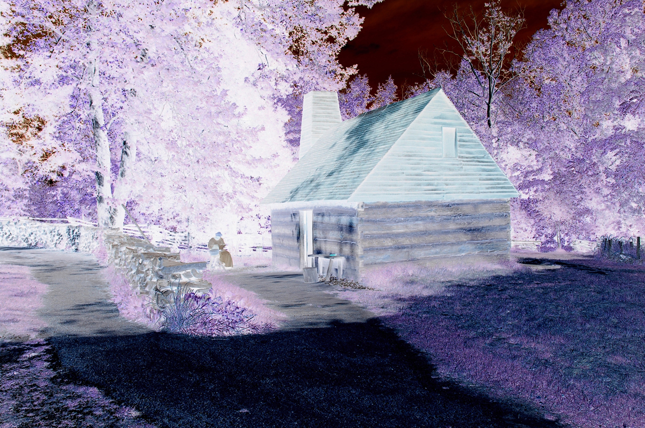

Under a blood red sky, Williamsburg, from the Half Seen Half Told series, VA, 2013, 20 x 30” Pigment print

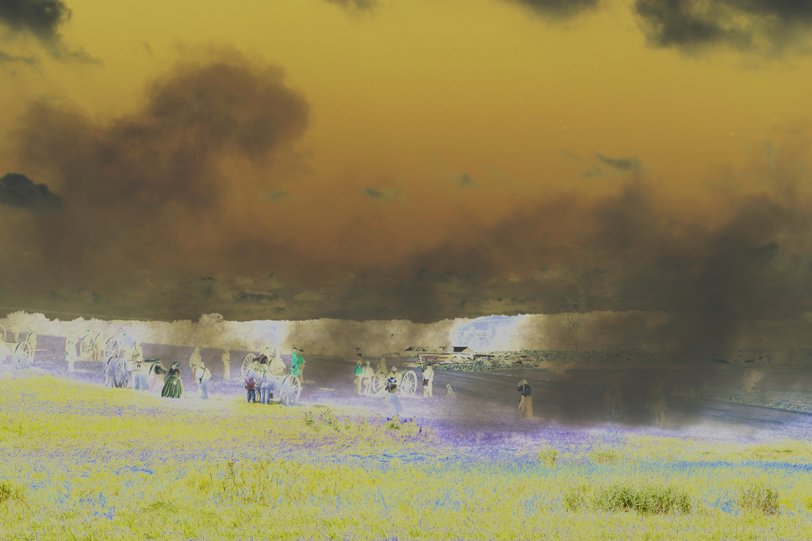

Over a blood-soiled land, Gettysburg, from the Half Seen Half Told series, PA, 2013, 20 x 30” Pigment print

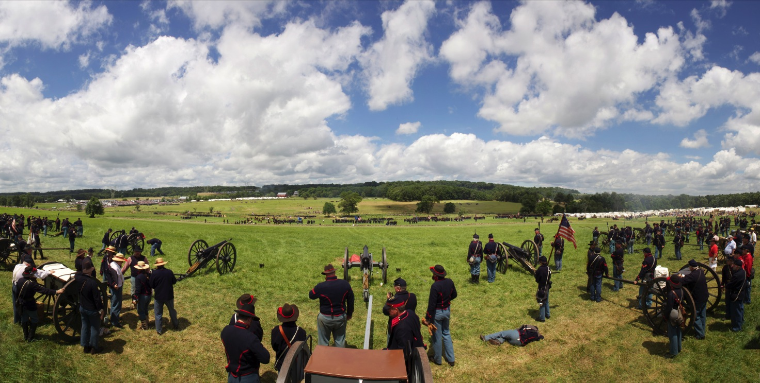

Heatstroke from the No Joke series, 18” x 40”, Pigment print, 2014

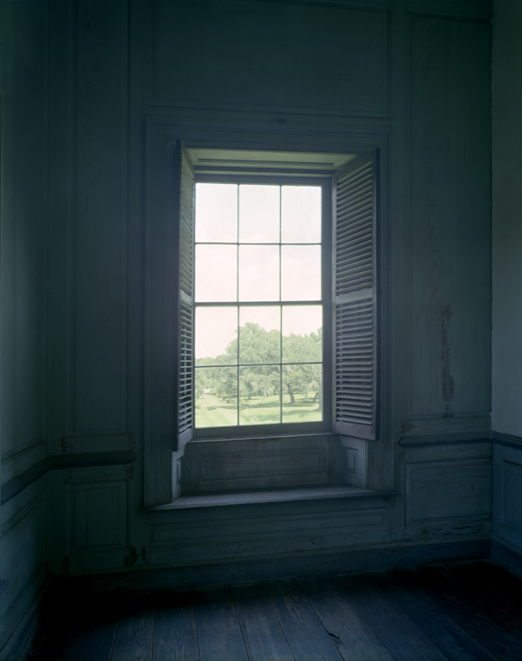
Single view, from the Asymmetry series, 2012, 50” x 40”, Type C print
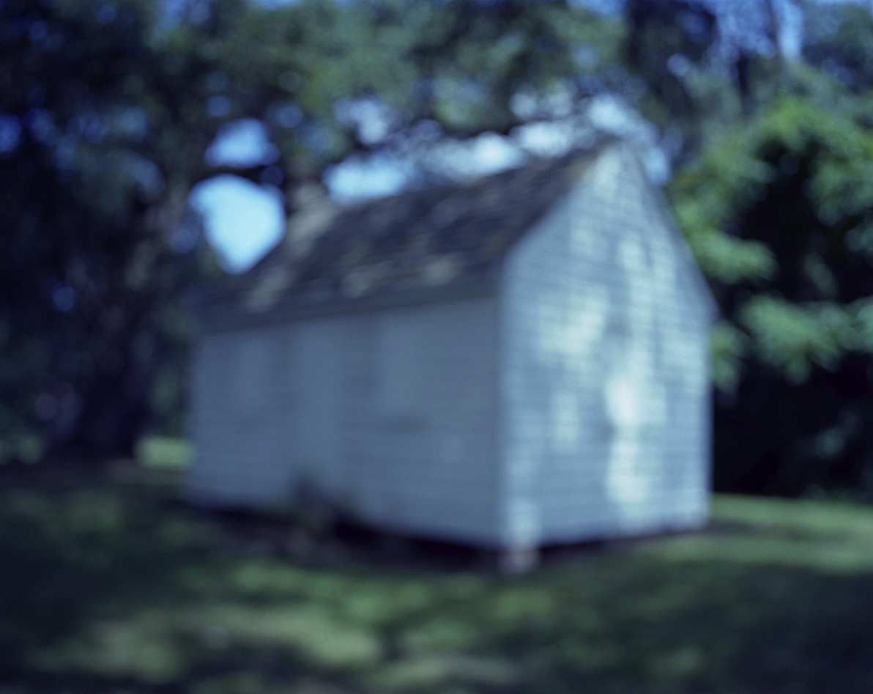

Half Seen, 2009/13, 40” x 50”, Pigment print

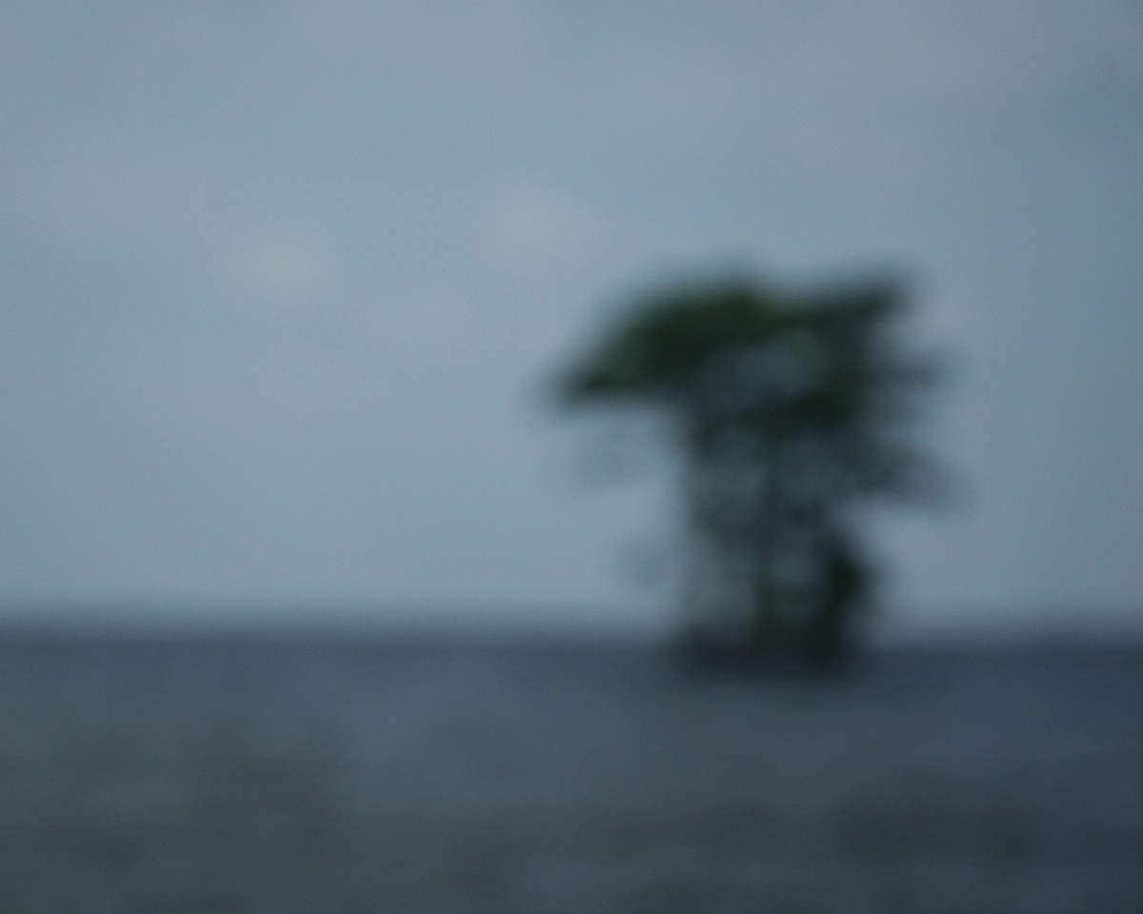

Half Seen, 2010/13, 40” x 50”, Pigment print
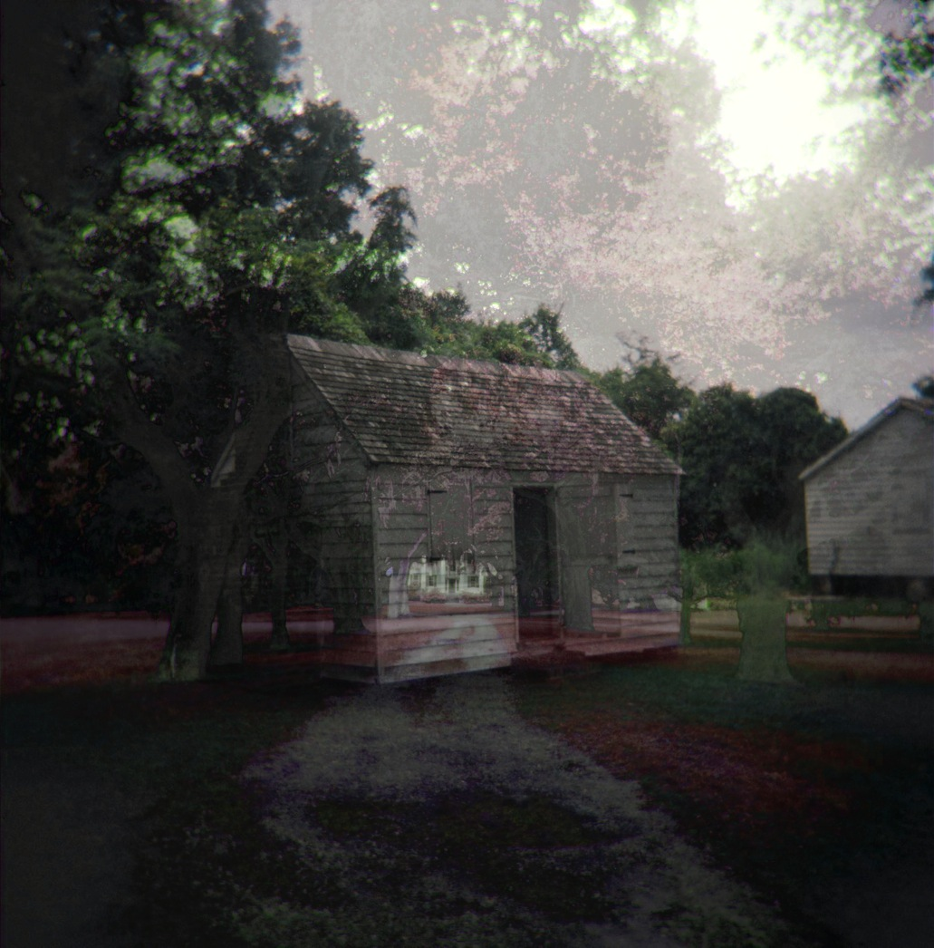 Half Seen Half Told #1, 2013
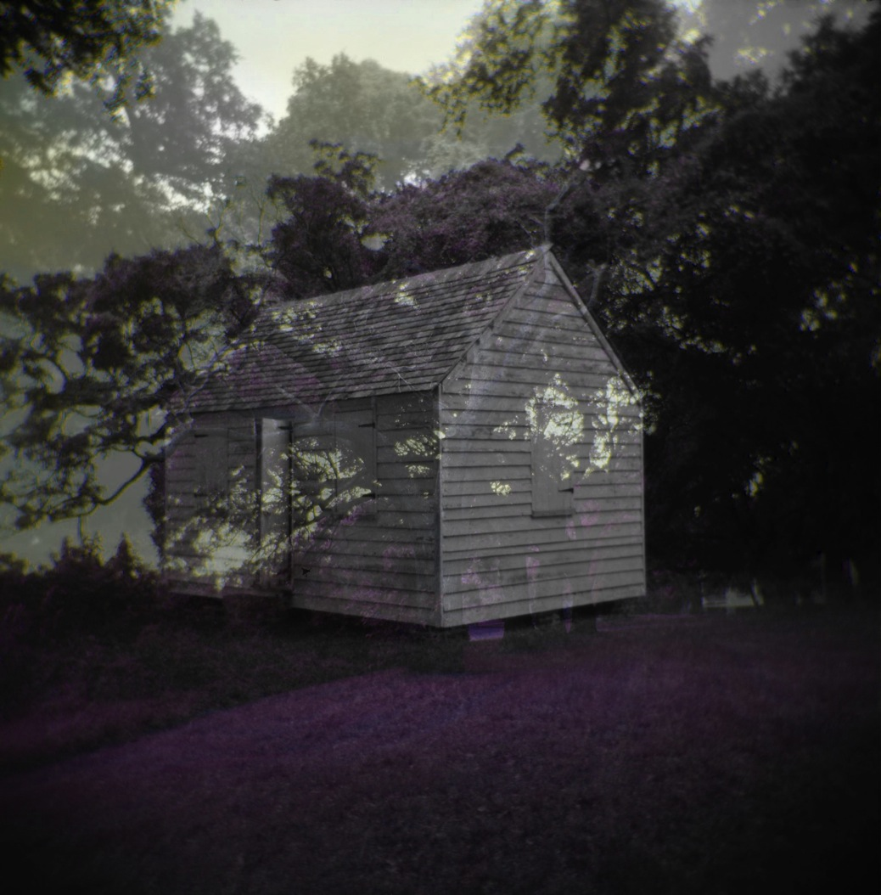 Half Seen Half Told #2, 2013

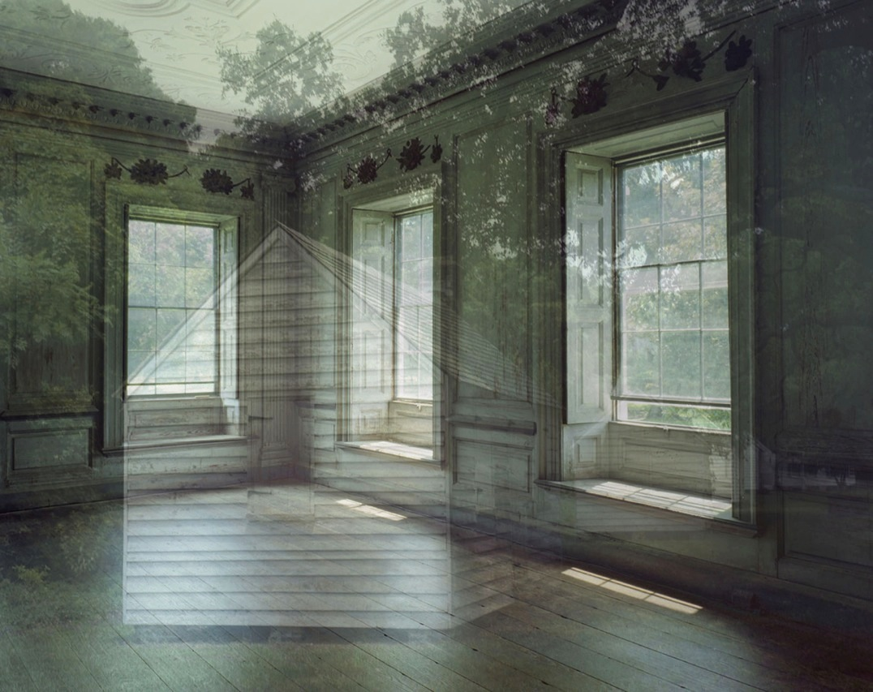

Untitled 1 from the Double Vision series, 2009, 40” x 50”, Type C print

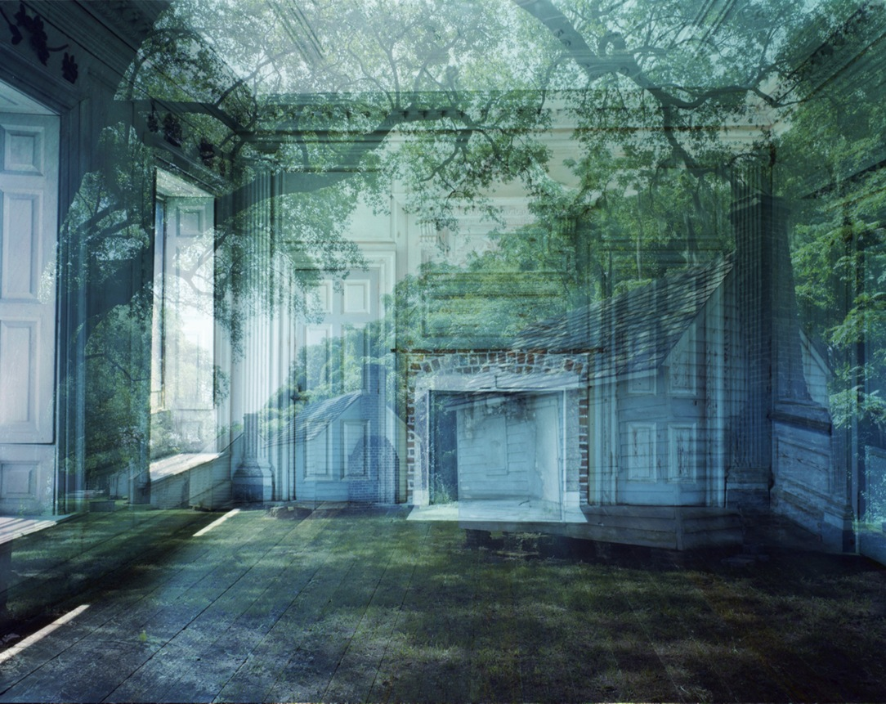

Untitled 2 from the Double Vision series, 2009, 40” x 50”, Type C print

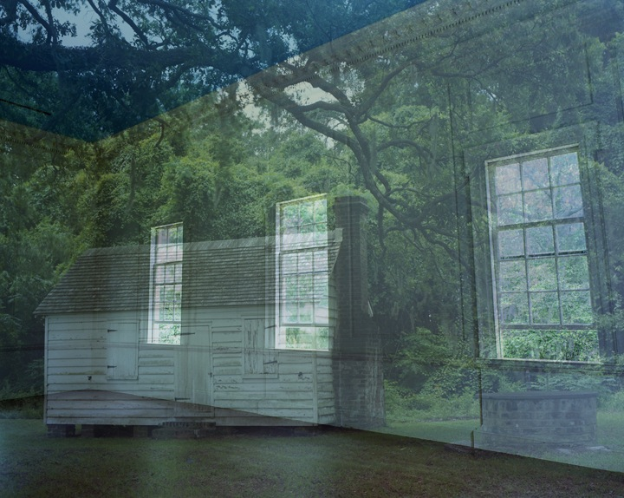

Untitled 3 from the Double Vision series, 2010, 40” x 50”, Type C print

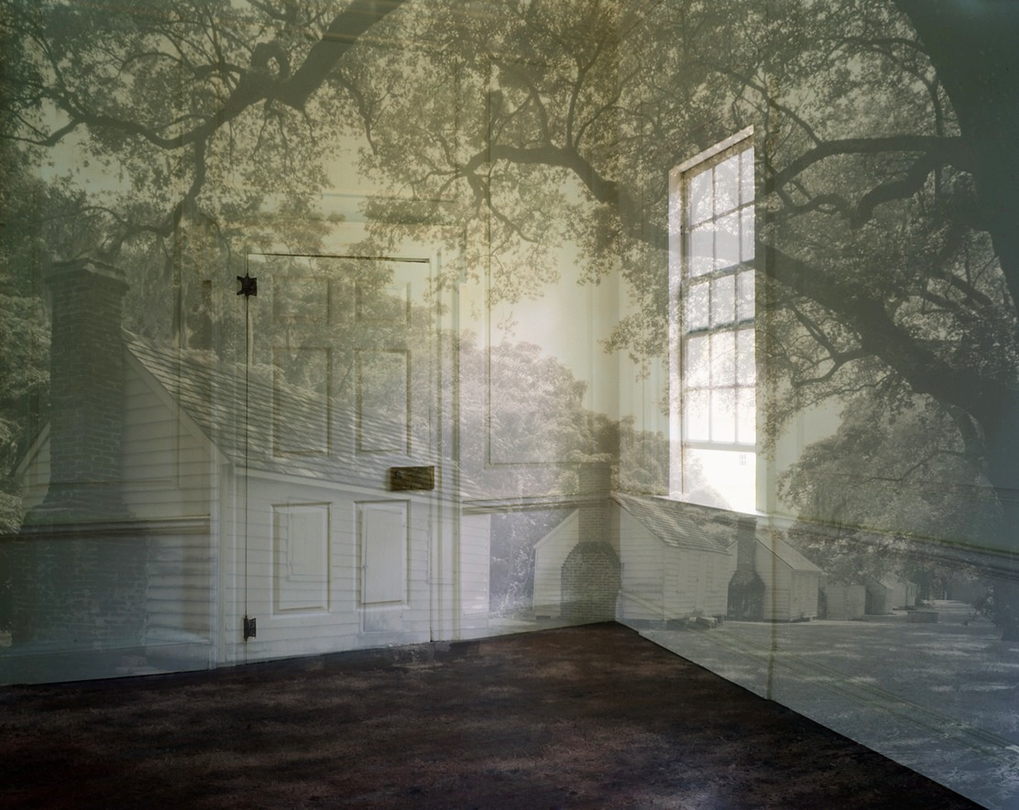

Untitled 5 from the Double Vision series, 2011, 40” x 50”, Type C print

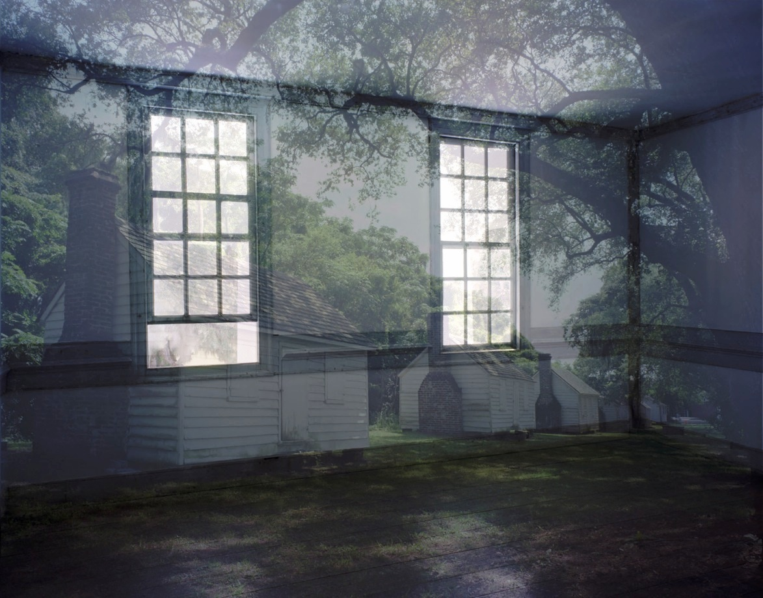

Untitled 6 from the Double Vision series, 2011, 40” x 50”, Type C print

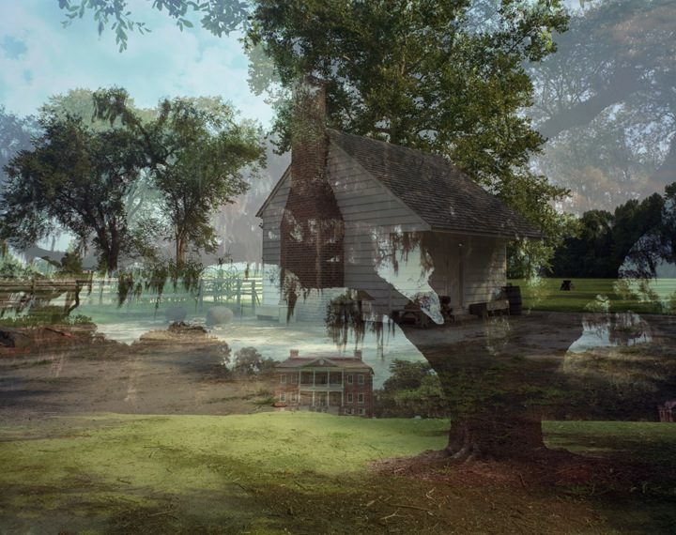

Untitled 8 from the Double Vision series, 2011, 40” x 50”, Type C print

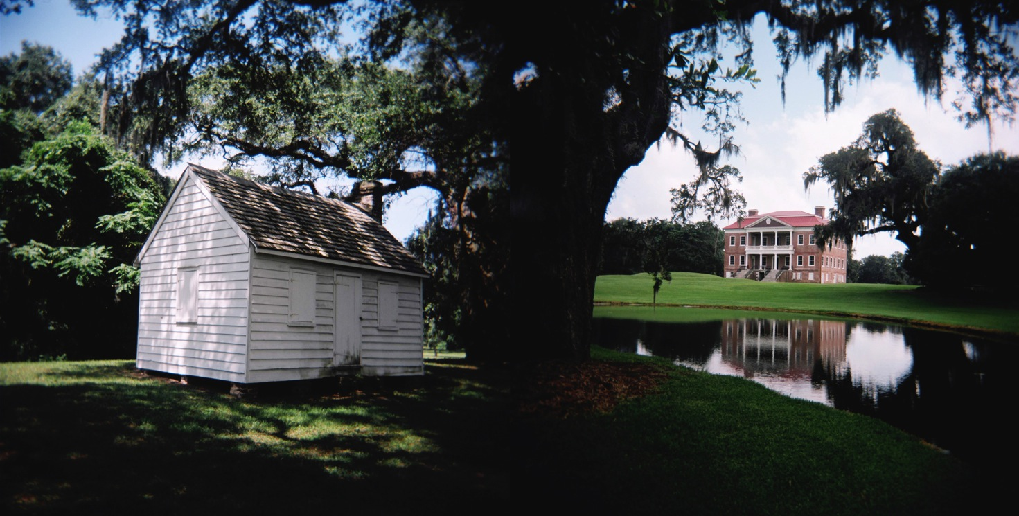
Forced from the Asymmetry series, 2011
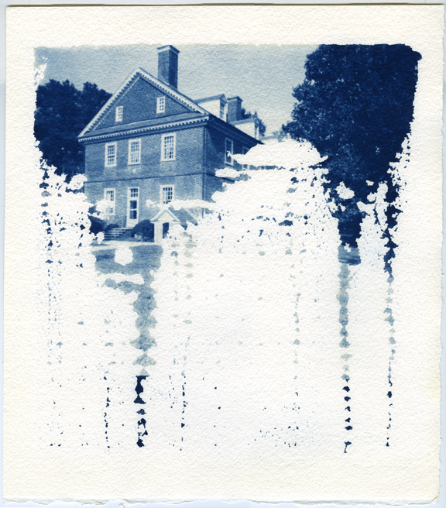

Bloodline (Berkeley Plantation, VA) from the Asymmetry series, cyanotype from pinhole film negative, 12 x 10”, 2009
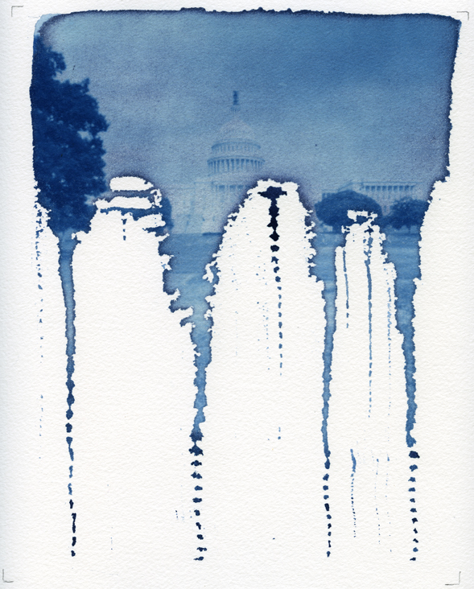

Bloodline (The Capitol, DC), from the Asymmetry series, cyanotype from pinhole film, 12 x 10”, 2011

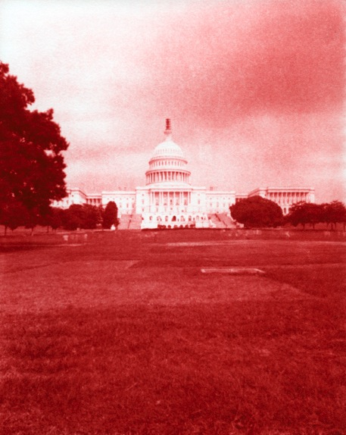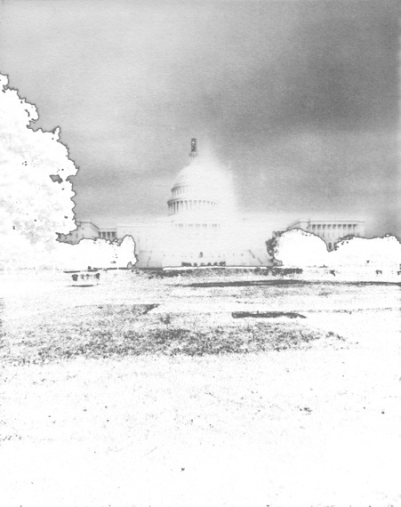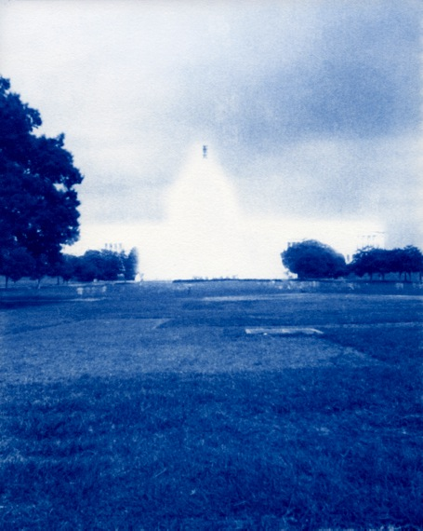

Bombs Away Dream Baby (Red White & Blue), 2009, 3 x 60 “x 45”, pigment prints

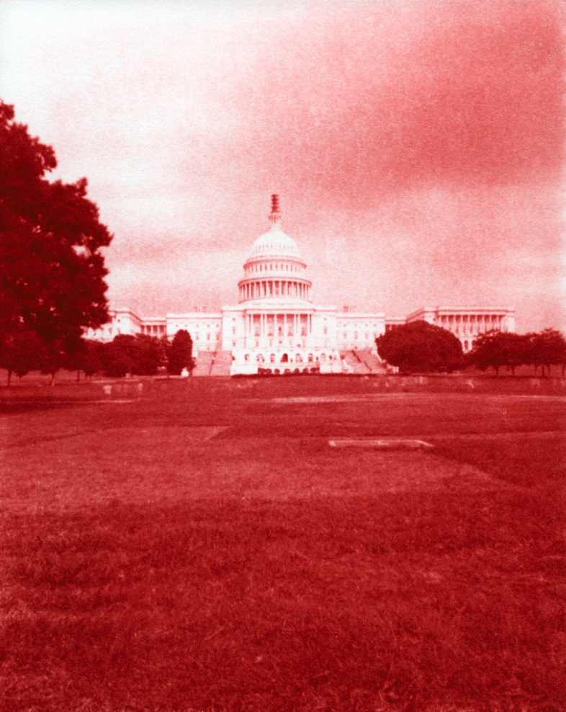
Bombs Away Dream Baby (Red), 2009, 60 “x 45”, pigment print
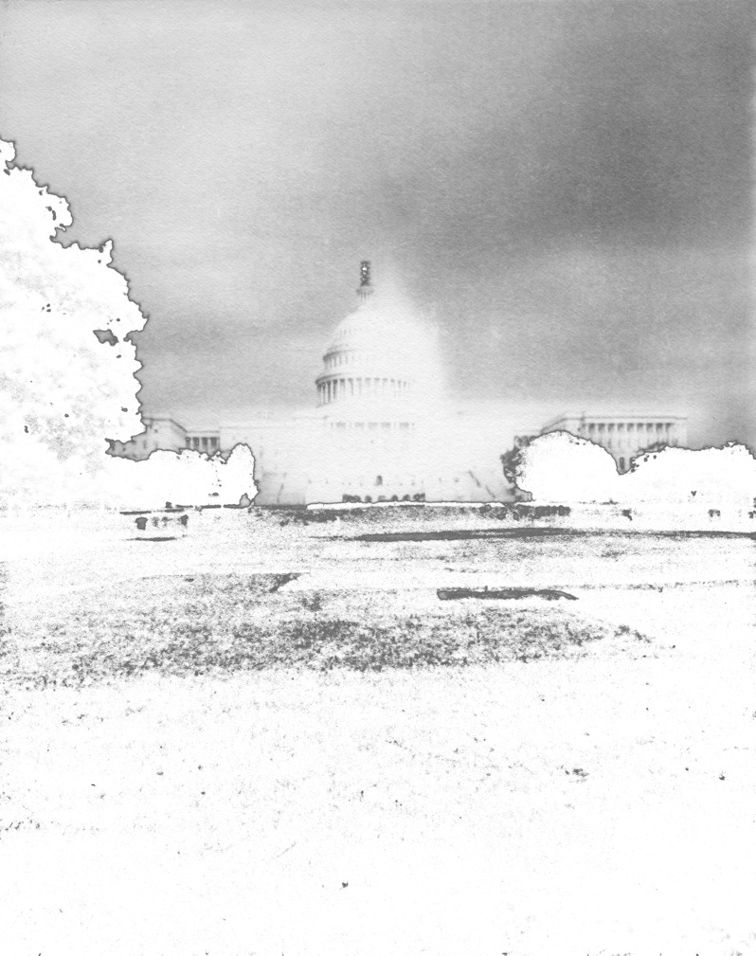
Bombs Away Dream Baby (White), 2009, 60 “x 45”, pigment print
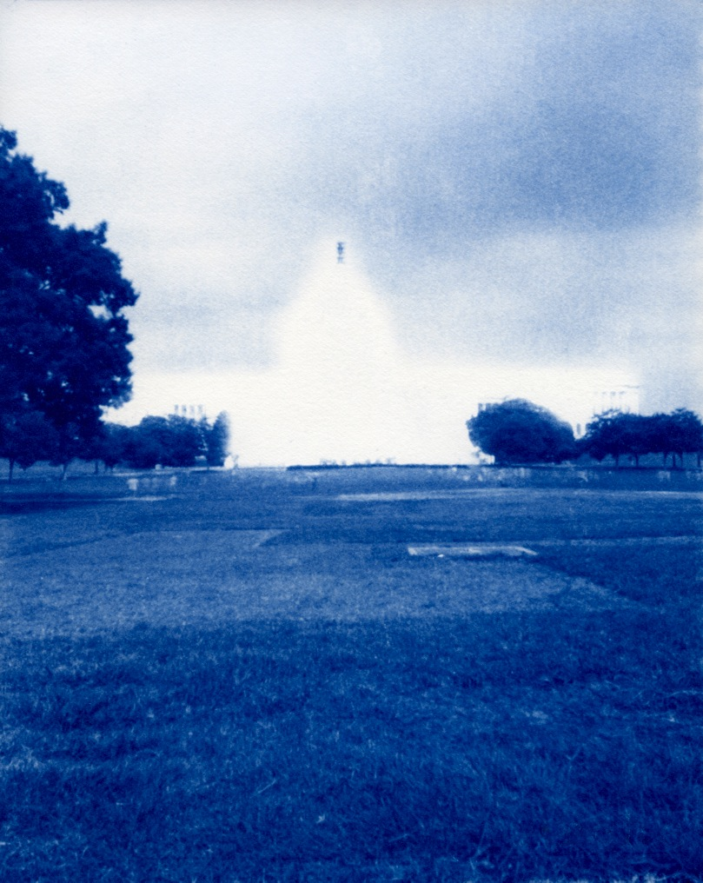
Bombs Away Dream Baby (Blue), 2009, 60 “x 45”, pigment print

